Using ITK Snap for Tumor Segmentation Correction

After running seg_edit, follow the command prompts and wait for an ITK Snap window to open. When a study loads, it should look like this:

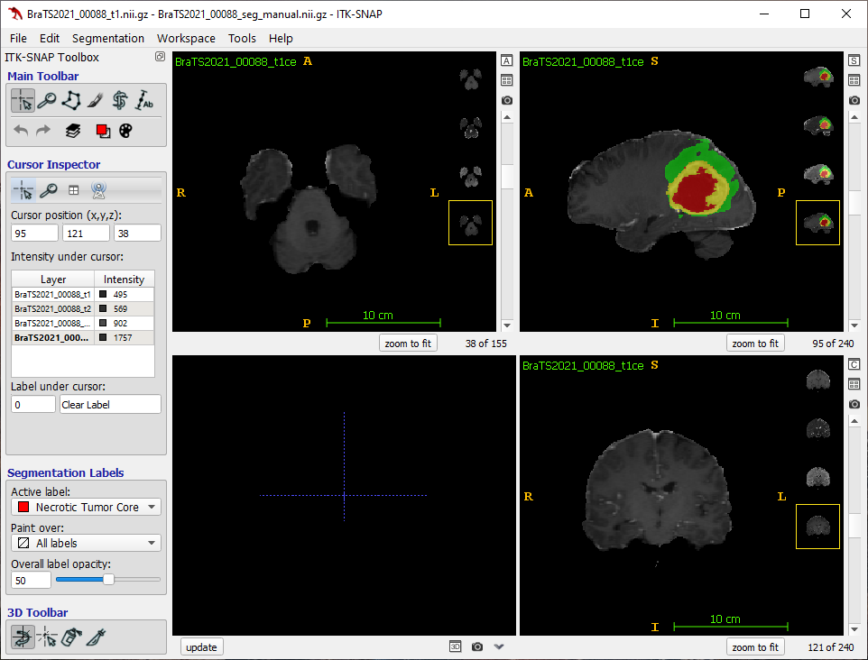



This is the **main toolbar**. This is used for switching between modes. We will only be using modes 1 (Crosshair) and 4 (Paintbrush). The remaining modes are not relevant for our purposes and will not be covered in this document. Use number keys 1-4 to quickly switch mdoes

This is the **Crosshair mode**. The 1 key is a shortcut. This allows easy panning, zooming, and scrolling with the mouse. Use this to rapidly move around the image.

This is the **cursor inspector**. This panel is visible when you are in Crosshair mode (hotkey = 1). Right clicking on any of the loaded images (layers) allows you to manipulate the window/level of each image independently.

This is the **Paintbrush mode**. The 4 key is a shortcut. Use this mode for actually performing segmentation corrections.

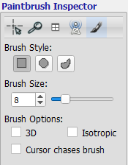This is the **paintbrush inspector**. This panel is visible when you are in Paintbrush mode (hotkey = 4).

**Brush Style**: In general, I find that the circle style brush is most useful for segmenting tumors, as they tend to be rounded.

**Brush Size**: Adjust with the arrows, slider, or with the + and – keys on your keyboard!

**Brush Options**: 3D turns your circle brush into a sphere brush. This is very useful for editing multiple slices at once. I almost always use the sphere brush, however you will need to check your work in other planes, since you won’t always see every slice you are editing. The isotropic option doesn’t do anything because our image data is already isotropic. Cursor chases brush changes the behavior when you click and drag the brush. I don’t find it helpful, so I leave it unchecked.

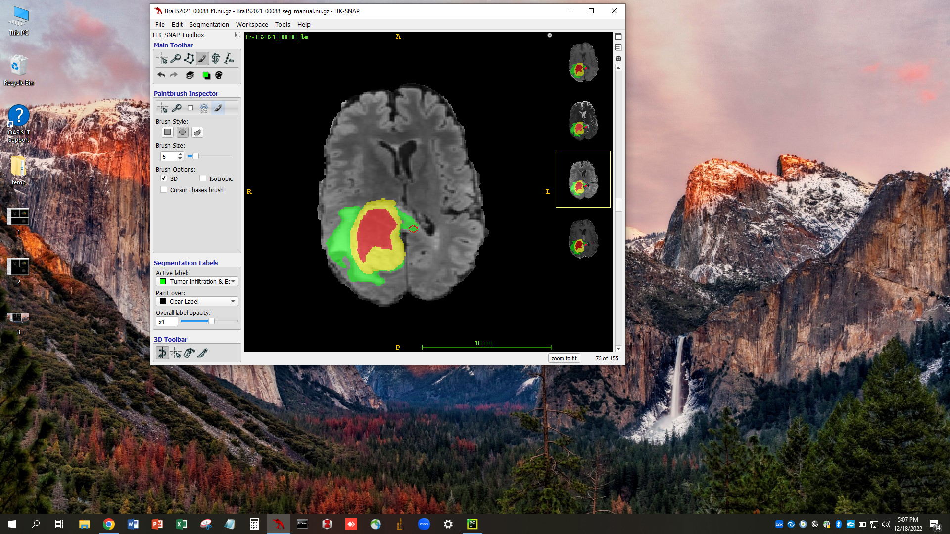This is the **Segmentation Lab**els panel. This is always open regardless of whether you are in Crosshair or Paintbrush mode.

**Active label**: Use this drop down menu to select which label you will be actively painting.

**Paint over**: Use this drop down menu to select which labels can be painted over by the active label. This can be all labels, the clear label (background) or any other label you choose.

**Overall label opacity**: Use this slider to adjust the overall opacity of the labels on the images in the viewer.

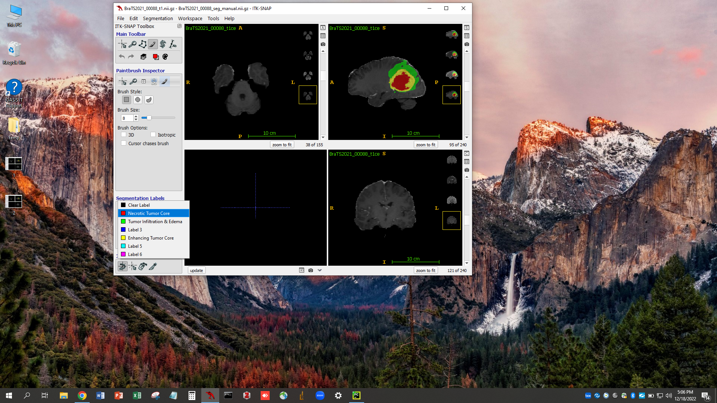All relevant labels should have label descriptions. The other labels without descriptions (for example Label 5) should not be used. Each label has its own unique color that will be displayed as a color overlay in the image window.

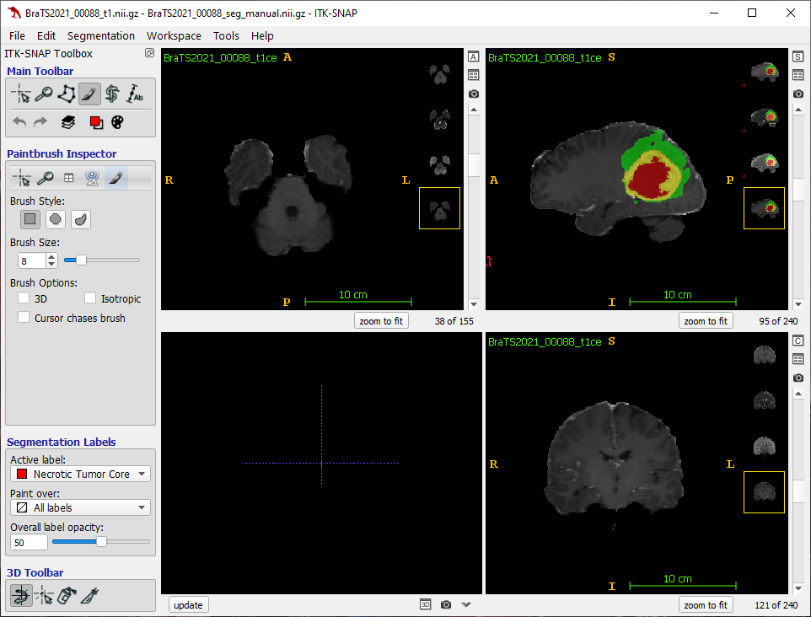This is the **image viewer window**. In the four-panel view (shown), the panels (clockwise from top left) are axial, sagittal, coronal, and 3D viewers. Within each of the orthogonal plane viewer windows, each of the available image contrasts is shown in a small thumbnail along the left side of the window. Click the thumbnail to quickly switch between image contrasts.

Each of the viewer windows can be expanded by pressing the button at the top right depicting a small window with the letter A for axial, S for sagittal etc. You can always return to the four-panel view using the four-panel button.

**Mouse controls:** In the image viewer window, the mouse wheel scrolls through images. While in **Crosshair mode** left click and drag scrolls and right click and drag zooms. While in **Paintbrush mode** left click paints with the active label and right click erases the active label. Clicking the mouse wheel and dragging will also zoom.

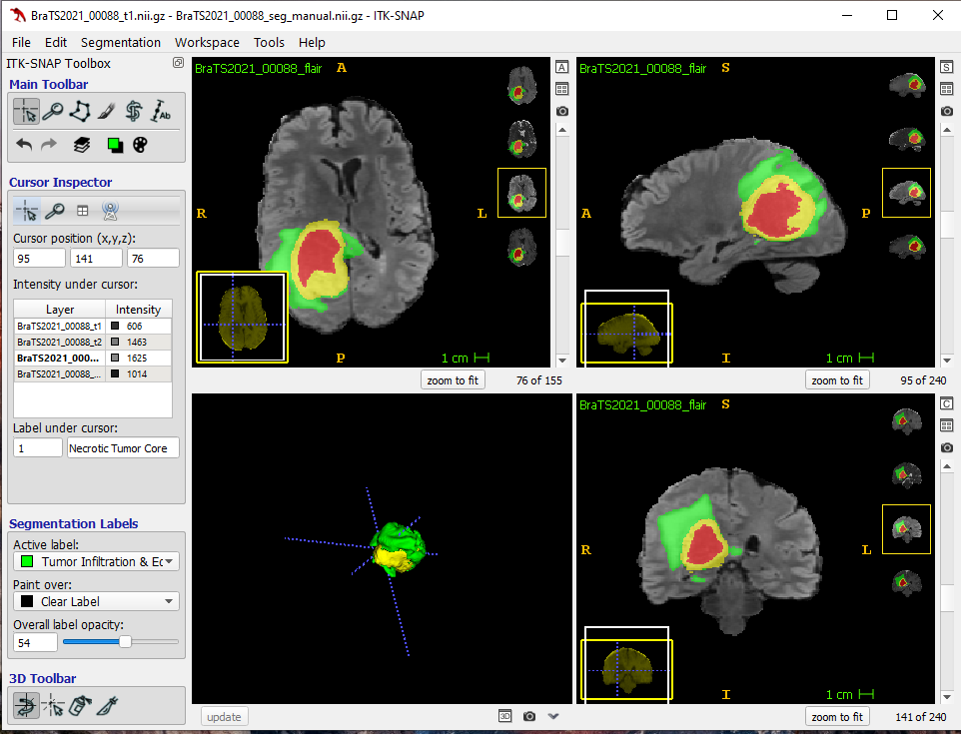**3D Mode**: Click the update button at the bottom left to view the segmentation in 3D. You will need to click update any time you make changes if you want them to show up in the 3D viewer. This can be useful for looking for sharp edges or accidental clicks.



In this example, I am manually correcting the Infiltrative Tumor and Edema compartment (green). There is infiltrative tumor extending across the genu of the corpus callosum that was not correctly captured. I am in **Paintbrush mode**. I have selected a **round brush**, a **brush size** of 6, and I have enabled the **3D (spherical) brush**.The **active label** is Tumor Infiltration and Edema. The **paint over** label is the clear label (since I do not want to paint over any of the other labels by accident). I can paint green with **left click** (with or without dragging). If I make a mistake, I can use ctrl+z to undo, or I can use **right click**. Since I am using the 3D brush, I will want to check adjacent slices (scroll wheel) and other planes to make sure my additions are correct. Alternatively I could use the 2D brush and segment independently on each slice.

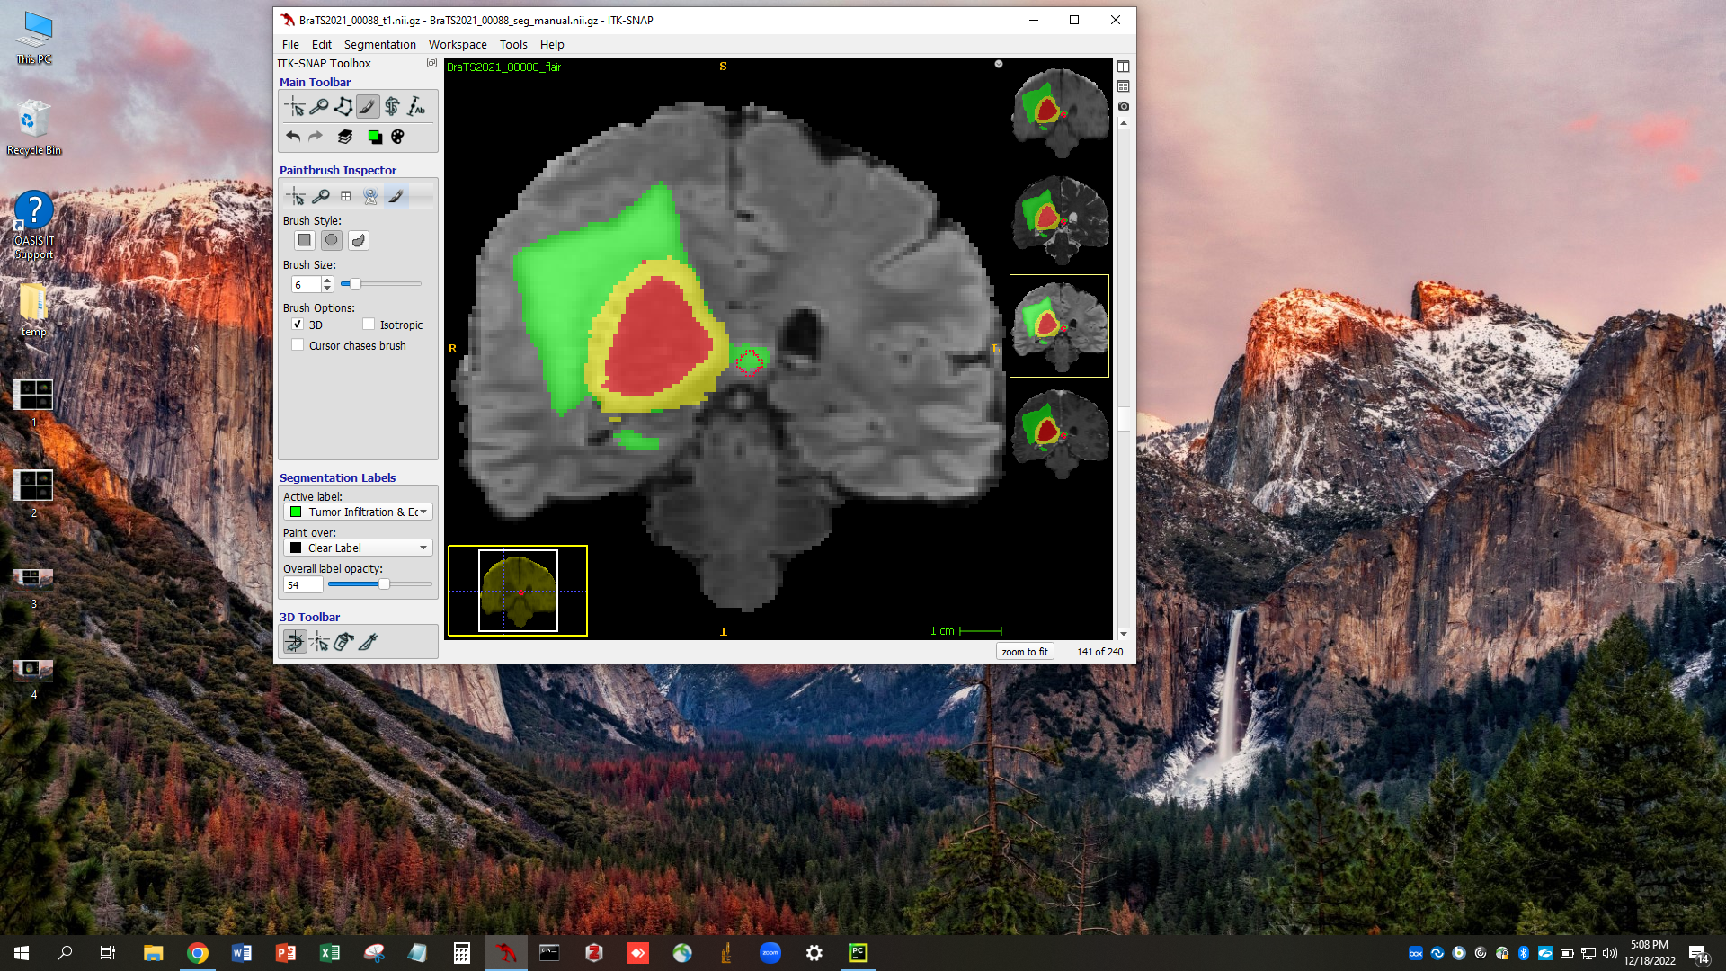

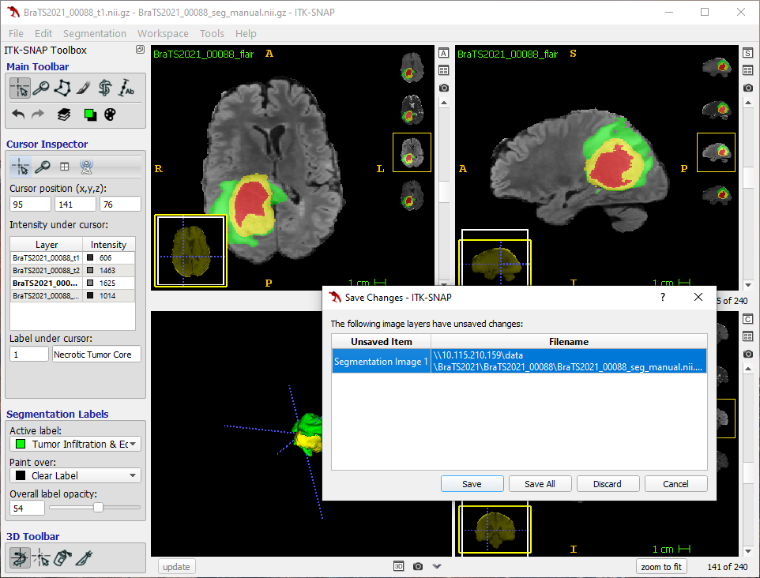Now I am confirming my edits in the coronal plane. I can also make edits in the coronal plane if I want to. Labels should always be checked in at least 2 planes.

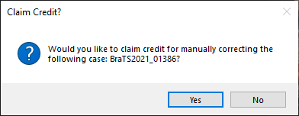**When I am done correcting all of the labels** all I need to do is click the X to close the ITK Snap window. If any changes have been made to the labels, you will automatically be prompted to save your data. Clicking “Save” or “Save All” will save your edits and the ITK Snap window will close. At this point, please wait for a prompt window to appear. If you do not see a prompt window in 5 seconds, then try to use Alt (or Apple key) + Tab to find the window.

The **prompt window** will ask if you want to claim credit for correcting the case you just closed. Click yes to finalize saving the corrected labels and claim credit. If you have made a mistake, you can always click No, which will delete the corrections you just made for this case (and will not claim credit).

Descriptions of Tumor Labels

**Enhancing tumor core**

This is the most straightforward label. This label encompasses **all tumor related enhancement**. This includes enhancing tumor as well as **any treatment related enhancement** (for postoperative and treated tumors). Obvious **linear postoperative enhancement does NOT need to be included in this label**. Only nodular enhancement is included in postoperative cases. Use your best judgement on whether or not to include debatable postoperative enhancement. **Make sure you are not including intrinsic T1 hyperintensity in this label!** Intrinsic T1 hyperintensity should either be necrotic tumor or resection cavity (for postoperative cases).

**Necrotic tumor core**

This label includes **non-enhancing tumor core**, which may be cystic or frankly necrotic, and is typically **circumferentially surrounded by enhancing tumor**. Rarely, you may find clear necrosis that is NOT surrounded by enhancement. In these cases, **use your best judgement on whether or not to include this portion** of the tumor in the necrotic tumor core. This tumor component may have intrinsic T1 hyperintensity or even FLAIR hyperintensity. **Do NOT use this label for mass-like FLAIR hyperintensity or non-enhancing infiltrative tumor**.

**Resection cavity**

For postoperative cases only, **this label encompasses the entire resection cavity**. This may contain blood products or debris and can be T1 hyperintense or FLAIR hyperintense. In some cases, **it may be difficult to separate resection cavity from necrotic tumor core**. Again, you will have to use your best judgement. **There may be circumferential enhancement around a resection cavity**; however, this does not mean that it is a necrotic core. Necrotic core typically develops from within an enhancing tumor focus.

**Tumor infiltration & edema**

This label includes **all abnormal tumor related brain parenchymal T2/FLAIR hyperintensity** that is not either enhancing tumor or necrotic core. This includes **mass like FLAIR and infiltrative tumor as well as tumor related edema.** This label **does not include obviously unrelated FLAIR signal abnormality such as microvascular ischemic change** or non-tumor related encephalomalacia. This is the largest label, and often circumferentially encloses the other labels. This label is frequently under-segmented, and can be difficult to manually correct given its ill-defined margins. As usual, use your best judgement.